 



**Development of an industry-based habitat mapping/monitoring system**

**Matthew Pember, Simon de Lestang and Dirk Slawinski**

**2017**

FRDC Project No **2011/021**

© Year Fisheries Research and Development Corporation.

All rights reserved.

ISBN **[Insert ISBN/ISSN – researcher to obtain - TBA]**

**Development of an industry-based habitat mapping/monitoring system**

**2011/021**

**2017**

**Ownership of Intellectual property rights**

Unless otherwise noted, copyright (and any other intellectual property rights, if any) in this publication is owned by the Fisheries Research and Development Corporation.

This publication (and any information sourced from it) should be attributed to **Pember, M., de Lestang, S. & Slawinski, D. Department of Primary Industries and Regional Development; Fisheries Division, Western Australia, 2017, Development of an industry-based habitat mapping/monitoring system, Perth, Western Australia, July.**

**Creative Commons licence**

All material in this publication is licensed under a Creative Commons Attribution 3.0 Australia Licence, save for content supplied by third parties, logos and the Commonwealth Coat of Arms.

Creative Commons Attribution 3.0 Australia Licence is a standard form licence agreement that allows you to copy, distribute, transmit and adapt this publication provided you attribute the work. A summary of the licence terms is available from creativecommons.org/licenses/by/3.0/au/deed.en. The full licence terms are available from creativecommons.org/licenses/by/3.0/au/legalcode.

Inquiries regarding the licence and any use of this document should be sent to: [frdc@frdc.com.au](mailto:frdc@frdc.com.au)

**Disclaimer**

The authors do not warrant that the information in this document is free from errors or omissions. The authors do not accept any form of liability, be it contractual, tortious, or otherwise, for the contents of this document or for any consequences arising from its use or any reliance placed upon it. The information, opinions and advice contained in this document may not relate, or be relevant, to a readers particular circumstances. Opinions expressed by the authors are the individual opinions expressed by those persons and are not necessarily those of the publisher, research provider or the FRDC.

The Fisheries Research and Development Corporation plans, invests in and manages fisheries research and development throughout Australia. It is a statutory authority within the portfolio of the federal Minister for Agriculture, Fisheries and Forestry, jointly funded by the Australian Government and the fishing industry.

|  |  |  |  |  |  |
| --- | --- | --- | --- | --- | --- |
| **Researcher Contact Details** | | **FRDC Contact Details** | | | |
| Name: Matthew Pember  Senior Resource Access Officer  Address: 56 Marine Tce, Fremantle 6160 WA  Phone: +61 08 9432 7777  Fax: +61 08 9432 7700  Email: [rao@wafic.org.au](mailto:rao@wafic.org.au) |  | | Address:  Phone:  Fax:  Email:  Web: | 25 Geils Court, Deakin 2600 ACT  02 6285 0400  02 6285 0499  [frdc@frdc.com.au](mailto:frdc@frdc.com.au)  www.frdc.com.au , |

In submitting this report, the researcher has agreed to FRDC publishing this material in its edited form.**Contents**

Acknowledgments 6

Abbreviations 6

Executive Summary 7

Introduction 11

Objectives 12

Methods/Results 13

Objective 1. Development of a cost-effective system for obtaining geo-referenced environmental information. 13

POTBot functionality 14

POTBot development 14

Initial design 14

Component Choice 16

Controller 16

Camera 16

GPS 20

Temperature Sensor 21

Data Storage 21

Power Source 21

Additional Supporting Components 22

Water Proof Housing 22

Placement in a lobster pot 24

Physical layout and construction 24

Programming 26

Objective 2. Trial implementation of system by industry to test concept. 27

Performance of POTBot v2 and 3 29

Objective 3. Cost-benefit analysis with conventional ground-truthing techniques. 31

Comparison of habitat mapping at the Leeman Closed area 31

Comparison of visual-based fin-fish monitoring 34

Discussion 36

Objective 1: Development of a cost-effective system for obtaining geo-referenced environmental information. 36

Objective 2: Trial implementation of system by industry to test concept. 37

Objective 3: Cost-benefit analysis with conventional ground-truthing techniques. 38

Conclusion 39

References 40

Implications 42

Recommendations 42

Further development 42

Extension and Adoption 42

Project Coverage 43

Project Materials Developed 45

Appendix 1. 46

Appendix 2. POTBot code. 47

**Tables**

**Table 1. List of the potential functionality of the POTBot and their associated importance, cost and difficulty of implementation. Grey rows represent functions chosen for implementation into the initial model. 20**

**Table 2. Spy camera trialled and their respective picture qualities. The camera chosen for integration into POTBot v1 Is highlighted in grey. 23**

**Table 3. Upgraded cameras for use in POTBot versions 2-4. 25**

**Table 4. Component costs for the development of POTBot version 3. 30**

**Figures**

**Figure 1.** Evolution of the various versions of the POTBot. 19

**Figure 2.** Wiring schematic of the POTBot, with permanent connections shown as solid lines and intermittent connections as dotted lines. Red, black and blue lines denote positive, negative and serial (data) connections, respectively. Transistors (T) and resistors (R) are shown. The external wires shown at the middle right are the wires running to the external of the water housing to detect the presence of water. 24

**Figure 3.** Schematic of the PCB board for the POTBot. 29

**Figure 4.** Flow diagram showing business rules followed by the POTBot versions 1-3 and its subsequent behaviour. 32

**Figure 5.** Map illustrating the spatial distribution of more than 1300 pot camera deployments made during research and normal commercial lobster fishing activities. The inset shows the key habitat categories observed inside and surrounding the research area at Leeman that is closed to lobster fishing and where high resolution bathymetric information was collected as part of FRDC 2008/013. 34

**Figure 6.** Relative causes resulting in a habitat classification not occurring from a POTBot deployment. 35

**Plates**

**Plate 1.** Breadboard linking power to an integrated circuit and an 808 camera, using a signal relay to connect a junction across the shutter button on the camera (paired white wires) (photo from http://quinndunki.com/blondihacks/?p=925). 17

**Plate 2.** High-pressure PVC pipe fitting housings used in POTBot v 2 and 3, showing clockwise from top right; entire housing with black screw cap on left, water sensing screw pins towards the centre and lens located on the right; closer shot of the water sensing screw pins with associate glue to ensure a tight seal; internal view of the housing showing the wires connected to the internal aspect of the screw pins; front of the housing with its clear Perspex lens. 23

**Plate 3.** Schematic of a lobster pot showing the location of the POTBot. 29

**Plate 4.** POTBot built on purpose-made PCB (green) with camera at the front, GPS visible towards the back and battery and Arduino mini located under the PCB; PVC underwater housing capable of deployments to greater than 180 m. 30

# Acknowledgments

We would like to thank Fisheries Research and Development Corporation for their financial support and all of the commercial rock lobster fishers who agreed to run POTBot systems in their fishing gear. We would also like to thank Ainslie Denham for help with the geo-statistical work in this report and Lachlan Strain, Scott Evans, Nick Blay and Nick Caputi for their help in reviewing.

# Abbreviations

BRUVs: Baited Remote Underwater Video Systems

CSIRO: The Commonwealth Scientific and Industrial Research Organisation.

DPIRD FD: Department of Primary Industries and Regional Development, Fisheries Division. Western Australia

FRDC: Fisheries Research and Development Corporation

MSC: Marine Stewardship Council

NMEA: National Marine Electronics Association

PCB: Printed Circuit Board

PCM: Pulse Code Modulation

POTBot: Pictures Of The Bottom

UWA: University of Western Australia

WCRLMF: West Coast Rock Lobster Managed Fishery

WAMSI: West Australian Marine Science Institution

# Executive Summary

Mapping / monitoring in the marine environment can be a very costly exercise. Scientists from the Department of Primary Industries and Regional Development; Fisheries Division (FD) and the Commonwealth Scientific and Industrial Research Organisation (CSIRO) have developed a small, low-cost automated camera system that, when fitted to commercial fishing gear, can achieve this at minimal cost. The POTBot (Pictures Of The Bottom) system is a cheap, small “smart” camera that can track its position globally and the date and time, and can record high-definition video and water temperature readings when it determines it has been deployed into the ocean.

Initially developed to be attached to pots in the West Coast Rock Lobster Managed Fishery (WCRLMF), the POTBot system collects vision of the habitats and the faunal communities where fishing gear has been set, and lasts for about a month of continuous commercial lobster fishing activity. When out of power, systems are simply swapped out for fresh ones / recharged and the collection of data continues at minimal costs.

Trials of the POTBot system conducted during this study have proved extremely valuable and have been used to augment the development of a number of spatial habitat maps off the west coast of Western Australia, as well as document the spatial and habitat distributions of a number of marine teleosts throughout the west coast bioregion. The POTBot systems have also proved to be a very valuable system for use in Baited Remote Underwater Video Systems (BRUVs) monitoring due to their robustness, automated capabilities and the geographic synchronisation of their footage.

The success of this project is highlighted by current plans to incorporate POTBot systems on a long-term basis into standard research programs: Western Rock Lobster monitoring program, FD BRUV monitoring programs and two recently approved Fishery Research and Development Corporation (FRDC) projects being conducted by the University of Western Australia (UWA). A number of interstate and overseas research institutes have also shown interest in obtaining this technology for use in their own research environments.

**Background**

A thorough appreciation of the nature and extent of the habitats a fishery operates across, and possibly impacts upon, is fundamental to the effective implementation of ecosystem-based fisheries management. The significance of reliable habitat information to sustainable management is highlighted by the fact that it may be considered a prerequisite for fisheries seeking to obtain, or retain, ecologically sustainable certification such as Marine Stewardship Certification (MSC).

In the case of the Western Rock Lobster *Panulirus cygnus*, current and recently completed projects (FRDC 2004/049, 2008/013) and the West Australian Marine Science Institution (WAMSI) node 4.3 (Corals of the northwest of Western Australia) have illustrated that the composition of benthic habitats may have a strong influence on the demographics of exploited species. While these projects provided high resolution information on benthic habitats at key locations, areas currently mapped at high resolution represent < 1% of the WCRLMF. The ability to expand mapping at a similar resolution was constrained by the large costs involved with current mapping techniques, e.g. multibeam sonar. In a recent audit report the MSC certifying body accepted the futility of expanding these surveys with high cost techniques and suggested a more broad-scale approach should be adopted in mapping the distribution of habitats in the WCRLMF.

**Aims / Objectives**

This project aimed to develop and trial the implementation of a cost effective tool for the ongoing collection of geo-referenced environmental information, including data on the composition and distribution of benthic habitats. The concept arose from the realisation that opportunities exist for greater industry involvement in collection of oceanographic and habitat data. Commercial Wester Rock Lobster fishers set pots on a daily basis and low-cost technologies are now available that have the potential to give them the ability to collect high resolution habitat data. Information could be collected across a broad spatial scale with no added cost or interruption to their fishing operation. The key objectives of the study were:

1. Development of a cost-effective system for obtaining geo-referenced environmental information.
2. Trial implementation of system by industry to test concept.
3. Cost-benefit analysis with conventional ground-truthing techniques.

**Methodology**

The project focussed on each objective sequentially. As such initial work was conducted on developing a POTBot system prototype. The requirements for the system were determined through interviews with marine scientists. The POTBot was designed to undertake a range of programmed tasks based on its detection of the presence of seawater (e.g. if the system was submerged or not).

Testing of prototypes was conducted in two phases: Initial laboratory testing and extended *in situ* testing.

a) Initial testing / selection of components was conducted within the laboratory (aquaria) at FD. This included activities such as submersion tests, image quality, power consumption and accuracy of measurements (e.g. global position and water temperature).

b) Extended testing was conducted in the field on board FD research vessels. This examined the components under working conditions and allowed for the refinement of programming to the behaviour of typical fishing operations.

Trial implementation of the system by industry followed on after FD field trials. A number of interested commercial Wester Rock Lobster fishers spanning the WCRLMF were provided with POTBot systems (~20 fishers) between 2012 and 2015. These trials tested the robustness of the POTBots to a commercial fishing operation, commercial fisher’s acceptance of units in their pots and collected initial habitat information throughout the WCRLMF.

A cost-benefit analysis comparing the POTBot system with conventional ground-truthing techniques was then conducted to help assess the value of implementing an on-going monitoring program using the system. As part of FRDC project 2008/013, a deep-water location in the WCRLMF was ground-truthed using the traditional techniques of drop-camera and towed video. These data and their associated costs have been fully recorded by the FD. As additional monitoring of the lobster population in this area occurs annually, it proved an ideal opportunity to fit POTBot systems into these pots and re-map the area using this innovative technology at no extra cost. The two sets of ground-truthed data were compared via geostatistical techniques, with indicator variables of the presence or absence of each habitat type being compared. The cost associated with the collection of the two sets of data was also compared.

A second cost-benefit analysis was undertaken following the use of POTBot videos to conduct an assessment of the spatial and temporal distributions of a number of key teleosts along the western Australian coast, from Kalbarri in the north to Mandurah in the south (Brooker et al. submitted). This study was compared to a study with a similar spatial coverage based on BRUV systems (Langlois et al., 2012). Again the ability of the two studies to determine teleost distributions and their associated costs have been compared.

**Results / Key findings**

This project was successful in developing a low cost automated geo-referencing camera system that can be deployed throughout a number of commercial fishing operations (i.e. operations which deploy fishing gear). At a unit cost of approximately $250 this technology is far more accessible for wide-scale implementation than other, less autonomous products available (e.g. GoPro at ~$500 unit-1).

The success of developing the POTBot was partly attributable to the recent rapid increase in the development of micro-electronic systems and robotics. Over the course of the project both lithium-polymer batteries and high-definition “spy” cameras became widely available in a range of sizes and at markedly reduced prices. Micro-controllers have also increased in their diversity and reduced in cost. This has allowed the POTBot to maintain a small size as well as low cost.

Analysis of both research and industry collected data is continuing. The collated habitat information has provided a map of the key habitats fishers operate across the extent of the WCRLMF and is currently being used to validate the fishery-wide habitat maps that have been developed from the outputs of a previous FRDC project (2008/013). These projects have directly resulted in the MSC re-certification of the Western Rock Lobster Fishery becoming free, for the first time, of any conditions under Principle 2 (Minimising environmental impact: What are the impacts? Fishing activity must be managed carefully so that other species and habitats within the ecosystem remain healthy). These projects have shown that there are no discernible impacts on the wider ecosystem from the Western Rock Lobster fishery.

Examination of fish community data from POTBot deployments highlighted the units’ versatility and cost-effectiveness as a fisheries monitoring tool that can be deployed using existing infrastructure. Although comparison against spatio-temporal variation in similar fisheries-independent or -dependent indices is required, preliminary results suggest that the method has potential as an alternative means for monitoring relative abundance of fin-fish.

POTBots were capable of producing data used to develop a habitat map that showed good agreement to a fine-scale high resolution map produced by combining a number of different methods including expensive side-scan sonar. This comparison shows that the use of POTBots can produce habitat maps far cheaper than can be produced based on the more traditional techniques of towed video and drop camera, especially if an area is to be fished for a separate purpose (e.g. fishery survey). Furthermore, the comparison with a BRUV fin-fish project suggests that the monitoring of marine fauna can also be conducted using POTBots at a fraction of the cost, so long as the area of the study is shared with a commercial fishery willing to adopt the POTBot fishing program.

**Recommendations**

The POTBot system developed during this study proved to be an extremely useful research tool. This has been highlighted by the fact that data collected during this project has already been used to describe the faunal composition of teleosts along the mid-west coast of Australia, as well as to augment the development of habitat maps throughout the same area. Through the use of this technology, information on habitats in remote areas has been recorded for the first time, information that will be valuable when determining long-term environmental changes in the future. Such a case has already occurred following the marine heatwave of 2010/11. It is recommended that, when appropriate, this technology be adopted by other research institutions to gather this previously inhibitively expensive data and long term data sets should start to be collated.

**Keywords**

Camera, POTBot, BRUV, marine, habitat, mapping, lobster fishery

# Introduction

A thorough appreciation of the nature and extent of the habitats a fishery operates across, and possibly impacts upon, is fundamental to the effective implementation of ecosystem based fisheries management. Understanding the relationships between benthic habitats and the species they support not only allows fishery managers to control against any potentially undesirable impacts on habitats, but also permits management to be more adaptive and spatially explicit. The significance of reliable habitat information to sustainable management is highlighted by the fact that it may be considered a prerequisite for fisheries seeking to obtain, or retain, ecologically sustainable certification, i.e. MSC certification.

In the case of the Western Rock Lobster *Panulirus cygnus*, current and recently completed projects

(FRDC 2008/013, 2004/049 and WAMSI 4.3) have illustrated that the composition of benthic habitats may have a strong influence on the demographics of exploited species. While these projects provided high resolution information on benthic habitats at key locations, areas currently mapped at high resolution represent < 1% of the WCRLMF. The ability to expand mapping at a similar resolution is constrained by the large costs involved with current mapping techniques, e.g. multibeam sonar. In a recent audit report the MSC certifying body accepted the futility of expanding these surveys with high cost techniques and suggested a more broad-scale approach should be adopted in mapping the distribution of habitats in the WCRLMF.

This project aims to develop and trial the implementation of a cost effective tool for the ongoing collection of geo-referenced environmental information, including data on the composition and distribution of benthic habitats. The concept arose from the realisation that opportunities exist for greater industry involvement in collection of oceanographic and habitat data. Commercial Western Rock Lobster fishers are setting pots in benthic habitats on a daily basis and low-cost technologies are now available that have the potential to give them the ability to collect high resolution habitat data. Information could be collected across a broad spatial scale with no added cost or interruption to their fishing operation.

The cost effectiveness of this system is the product of an innovative use of relatively inexpensive technology and the direct involvement of stakeholders in data collection. Recently, fishers have participated in a study using modified research pots where the location of pot sets is recorded along with catch information. In addition to detailed demographic data, that project is beginning to provide researchers with a broad-scale picture of the spatial distribution of fishing operations across different parts of the WCRLMF and fishing season. Outputs of the modified pot trials could be greatly expanded if habitat information could be easily collected for each pot set.

Besides informing researchers and managers of the broad-scale habitat patterns found across the WCRLMF, this system could represent a cost-effective method of collecting the habitat information required to validate predictive habitat models. Furthermore, the information provided will fine-tune habitat / Western Rock Lobster relationships developed in previous projects. Wide and continuous deployment of systems throughout the WCRLMF will allow researchers to quantify how such relationships change with latitude and depth and vary temporally.

In addition to mapping habitat, these technologies are capable of collecting a range of other important data including spatial information on salinity, water temperature and depth, and the relative abundance / species composition of finfish. Ultimately, increased knowledge of the interactions between the environment and exploited species will foster more holistic and adaptive fisheries management. While the project concentrates on the fishery for the Western Rock Lobster in a proof of concept study, the technologies have far wider applications, particularly for small or data poor fisheries.

A thorough understanding of the relationships between benthic habitats, exploited species and the fisheries they support increases the capacity for fisheries management to be ecologically sustainable and adaptive in the face of climate change and spatial zoning.

Improving knowledge of such relationships typically requires a significant commitment of resources, i.e. swath-mapping and dedicated ground truthing. Costs are prohibitive of continuous spatial coverage and the snap-shot nature of data acquisition provides little confidence that habitat relationships persist through time.

There is a real need for a more cost-effective approach to collecting oceanographic and habitat information. This project develops and implements a system capable of providing constantly updating, geo-referenced environmental data, including information on the composition of benthic habitats.

This project addresses key priorities of FRDC’s Ecological Sustainable Development theme. Specifically, the project will:

- develop a cost-effective tool that aids in the implementation of ecosystem-based fisheries management.

- improve the acquisition and incorporation of environmental / habitat data into fisheries management.

- improve knowledge of key biological attributes for target species.

In addition, this project contributes to other environment related RD&E priorities by:

- informing on the likelihood, and thus mitigating the impacts, of fishing activities on aquatic habitats and ecosystems.

- providing a tool to monitor fishing gear interactions with non-target species.

- contributing to industry’s ability to adapt to climate change by providing a tool to monitor real-time changes to oceanographic conditions, benthic habitats and relationships with exploited species.

In the case of the Western Rock Lobster, this research ensures continued MSC certification by addressing requirements that “the nature and distribution of habitats relevant to the fishing operations is known”. However, the needs addressed by the project are not specific to the WCRLMF. This technology is transferable to other fisheries and has particular application to data poor fisheries.

# Objectives

1. Development of a cost-effective system for obtaining geo-referenced environmental information.
2. Trial implementation of system by industry to test concept.
3. Cost-benefit analysis with conventional ground-truthing techniques.

# Methods/Results

## Objective 1. Development of a cost-effective system for obtaining geo-referenced environmental information.

The cost-effective system for obtaining geo-referenced environmental information has been named POTBot. The model that was used for field trials and the cost-benefit analysis was the third product in a series of prototypes that were developed. The evolution of the various prototypes was due to the concurrent expansion and increase in accessibility of micro-computers, batteries and camera systems. What was available and possible at low cost towards the end of the project was substantially different from what was available at the beginning. The evolution in development of the POTBot is shown in Figure 1 and described below.

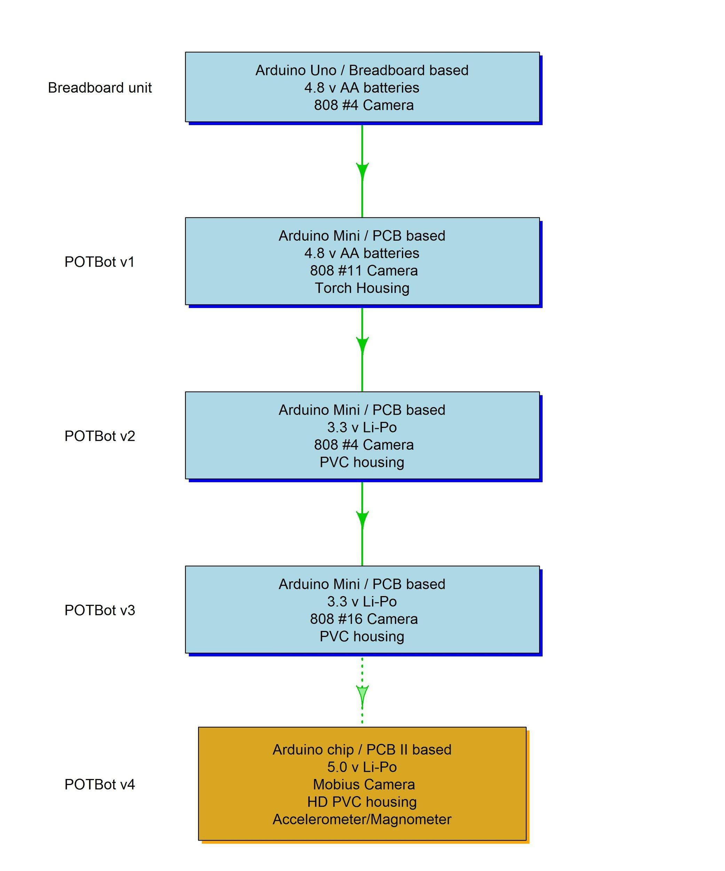

**Figure 1.** Evolution of the various versions of the POTBot. Note version 4 was developed subsequent to the analyses described in this report.

### POTBot functionality

In order to develop the camera system, literature and internet reviews were first conducted to determine what functions were available that could be incorporated into the system. This included contacting other marine researchers to see what was on their “wish list” for such a device. The potential functionality of a POTBot system was then compiled from the reviews along with their associated general costs and ease of implementation (Table 1).

**Table 1.** List of the potential functionality of the POTBot and their associated importance, cost and difficulty of implementation. Grey rows represent functions chosen for implementation into the initial model.

|  |  |  |  |
| --- | --- | --- | --- |
| **Functionality** | **Importance** | **Implementation Difficulty** | **Relative cost** |
| *Good quality vision (1280 x 720 pixels)* | *3* | *1* | *2* |
| High Definition vision (1920 x 1080 pixels) | 2 | 2 | 2 |
| Stereo vision (twin lenses) | 1 | 2 | 2 |
| *Determine position (GPS)* | *3* | *1* | *2* |
| Lights | 1 | 3 | 2 |
| *Data storage* | *3* | *1* | *1* |
| *Measure temperature* | *2* | *1* | *1* |
| Measure salinity | 1 | 3 | 2 |
| Measure depth | 2 | 3 | 3 |
| Measure orientation / movement | 1 | 1 | 1 |
| Measure water movement / current | 1 | 3 | 3 |
| *Depth rated to 100 m* | *3* | *1* | *1* |
| Depth rated to 200 m | 2 | 2 | 2 |
| Depth rated to 1000 m | 1 | 3 | 3 |
| *Small size* | *3* | *2* | *2* |
| *Long battery life (>30 days)* | *3* | *3* | *2* |
| *Ease of use* | *3* | *2* | *2* |
| Blue-tooth connectivity | 1 | 3 | 3 |
| Wireless charging | 1 | 3 | 2 |

1 = low, 2 = medium, 3 = high

From the review process it was considered possible that a basic model could be developed that contained all of the high priority functions fairly easily (grey rows in Table 1). As such it was decided to initially develop this basic version for trials prior to examining the possibility of upgrading various aspects. The initial model included the capabilities of the functions highlighted by the grey rows in Table 1 (POTBot v1).

### POTBot development

#### Initial design

Once the general capabilities of the system had been determined a second review process was undertaken to determine whether:

* a system such as POTBot v1 currently existed;
* a similar system existed that could be modified to suit our purposes;
* the components of POTBot v1 existed and could be amalgamated to suit our purposes;
* the components did not all exist and some would have to be built from the ground-up.

A number of camera systems were available for sale, of which some were water proof (with associated housings), some were programmable and could geo-reference images/video, some were small and some had low power demands. However, no pre-made systems were found that provided the entire functionality of POTBot v1.

A number of systems that had similar functionality to POTBot v1 already existed and essentially only needed waterproof housings developed. These systems were smart phones. They contain cameras with geo-referencing capabilities, magnetometers and accelerometers to determine orientation and acceleration, respectively, and data storage capabilities. They also could utilise external power sources to extend their run-time into weeks. There were however, two main limitations to adapting a smart phone into POTBot v1. They are relatively expensive (> $400 per unit) and they required custom-made waterproof housings. A housing to fit a rectangular object with a camera on its largest face (standard smart phone layout) requires either a rectangular housing or a relatively large cylindrical housing. An objective of the project was to develop a small unit so the large cylindrical housings were not considered appropriate. Rectangular housings presented structural issues for deployment at depth and were therefore very difficult and expensive to construct (> $300 per unit). The programming of mobile phones further requires specialised skills as their software platforms have very technical solutions to problems such as power saving, which are quite difficult to modify to suit the requirements of the POTBot v1. As such it was not considered the best course of action to re-purpose a smart phone.

The various components of the POTBot v1 system were found to already exist, with the majority of functions capable of being completed by a number of different components, thus providing choice. This diverse range of products available allowed their accessibility and cost to be factored into whether they were chosen to be integrated. For example, for the video camera alone over 50 products fitted the brief of being small, providing a minimum of 1280 x 720 pixel resolution, having relatively low power demands, being externally controllable and having a relatively low cost. Another advantage of integrating specific components was the removal of superfluous components with their associated power demands. For example, a smart phone will poll for and analyses phone signal coverage strength. This unnecessarily utilises power and is not required for integration in the POTBot v1. Therefore the option of combining specific components proved to be the most power conservative. The development of POTBot v1 from pre-existing components was chosen as the best model.

#### Component Choice

##### Controller

To achieve the chosen functionality of POTBot v1 the system needed a camera, GPS, temperature sensor (thermistor), data storage unit, power source and water proof housing. The system also needed a central-controlling unit, something to turn the camera on and off, determine the geographic position and record this information. Of the available options it was initially clear that one of the many micro-controllers available was a good option ($15 - $50), with the open-source nature of their software and large communities providing online scripting help. Controllers compared were the BeagleBone units (<https://beagleboard.org/>), Raspberry Pi units (<https://www.raspberrypi.org/>) and Arduino units (<https://www.arduino.cc/>). Generally the three platforms had similar functionalities and capabilities, with the main difference being the Arduino’s lower power usage (due in part to its lower processor power). The Arduino also had the ability to enter into a sleep mode, thus further reducing (66%) its power usage. The very small footprint of the Arduino Mini, its low cost (~$15) and its ability to run on either 3.3 or 5 v made this board our choice for controlling the POTBot v1 (<https://www.arduino.cc/en/Main/arduinoBoardMini>). However, due to the mini’s small size and design, an Arduino Uno (<https://www.arduino.cc/en/Main/ArduinoBoardUno>) was initially used for the development and solderless bread boarding of POTBot v1 (Plate 1; a board containing a number (+50) of interconnected pins that allow easy connection of a number of wires/components: see <https://en.wikipedia.org/wiki/Breadboard> for more information on breadboards). The main features of the Uno that made it more appropriate for the development stage was its pin structure, which did not require soldering (header pins are pre-built) and the easier serial connection of the Uno to the computer for two-way communication (i.e. uploading software and receiving Arduino outputs).

##### Camera

A number of small camera units were examined and trialled. The recent boom in the prevalence of small low-cost spy-cameras proved beneficial for this project. The benefits of these camera units was that they were all very cheap ($1 - $40) and small (< 50 mm long and <10 mm thick), they contained very advanced post processing software for compressing large video files and storing all of the footage on small microSD cards, they all use 3.3 v power sources (can generally handle from 3 – 5 v) and their usage is simplified (minimal button presses to take and stop video footage). The only real limitation of these cameras was the quality of some of the unit’s footage (even though they were described as 1280 x 720 px). As such twelve commonly advertised “spy” cameras were purchased and trialled. A list of these initial cameras trialled, their cost and sources are listed in Table 2.

Of the twelve spy cameras trialled the Mini 808 Car Key Chain Micro Camera HD 720P #4 was chosen for integration into POTBot v1 due to its good quality video and low price ($25). This camera contained two push-button switches to turn it on and off and to start and stop videos being recorded. This camera could be controlled by the micro-controller board through the soldering of two wires onto opposite poles of each of the two switches and allowing the controller to ”join” these wires thus replicating a press of the switch (Plate 1). The joining of the two wires was achieved using a NP transistor (Figure 2 & Figure 3). Although not true 1280 x 720 px (the frame is up scaled from 640 x 480 px with interpolation making it appear to be 1280 x 720 px) the quality of the video was more than sufficient, especially for the development phase. The power usage of this camera was 130 mA when on but not recording and 160 mA when recording a video.

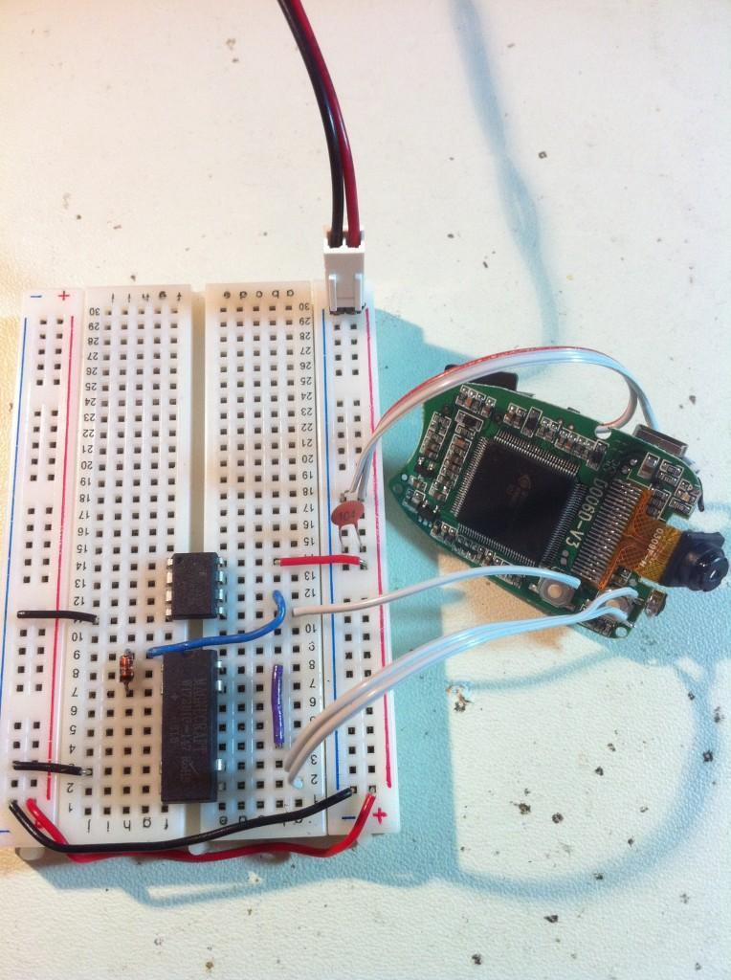

**Plate 1.** Breadboard linking power to an integrated circuit and an 808 camera, using a signal relay to connect a junction across the shutter button on the camera (paired white wires) (photo from <http://quinndunki.com/blondihacks/?p=925>).

**Table 2.** Spy cameras trialled and their respective picture qualities. The camera chosen for integration into POTBot v1 is highlighted in grey.

|  |  |  |  |
| --- | --- | --- | --- |
| **Camera name** | **Source** | **Cost** | **Picture quality** |
| Mini DV Spy Lighter Camera Hidden Camera Video Recorder | Ebay  #190447659725 | $1.84 | Low |
| New 808 Keychain Key chain keyring mini spy camera DVR #1 | Ebay  #370430370782 | $2.50 | Low |
| 808 #3 Car Key Spy Camera fob Camcorder keyring | Ebay  #150567816880 | $24.00 | Medium |
| Mini 808 Car Key Chain Micro Camera HD 720P #4 | Ebay  #110280524362 | $24.95 | High |
| Mini DV Spy Lighter Camera Hidden Camera Video Recorder | Ebay #190447659725 | $19.56 | Medium |
| 909 Mini Car Keys Shape DVR Spy Camera support TF card | Ebay #320612800707 | $16.99 | Medium |
| Flashlight Video Camera Spy MINI DV LED Night vision-IR | Ebay  #400170448477 | $29.99 | High |
| Mini DV DVR Sports Video Camera Spy cam MD80 spycam DC | Ebay  #170477360104 | $12.65 | Medium |
| NEW HD 1280*960 Hidden Spy Mini DV Camera Video Cam Camcorder Motion Detection | Ebay  #320779431551 | $39.20 | High |
| NEW 8GB HD 1280 x 960 Hidden Spy Mini DV Camera Video Camcorder Motion Detection | Ebay  #170791427941 | $39.95 | High |
| Mini GSM SIM Card Hidden Spy Camera Audio Video Record X009 DV Ear Bug Monitor | Ebay  #400963922767 | $19.28 | Medium |

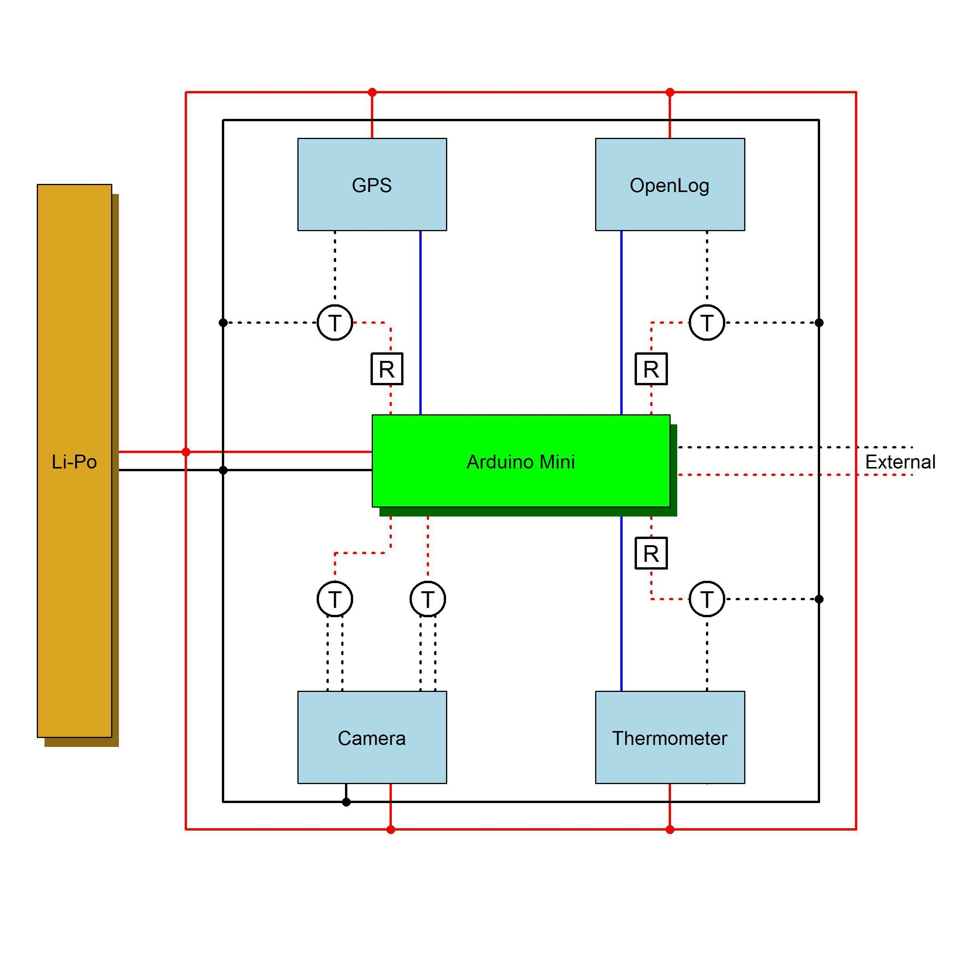

**Figure 2.** Wiring schematic of the POTBot, with permanent connections shown as solid lines and intermittent connections as dotted lines. Red, black and blue lines denote positive, negative and serial (data) connections, respectively. Transistors (T) and resistors (R) are shown. The external wires shown at the middle right are the wires running to the external of the water housing to detect the presence of water.

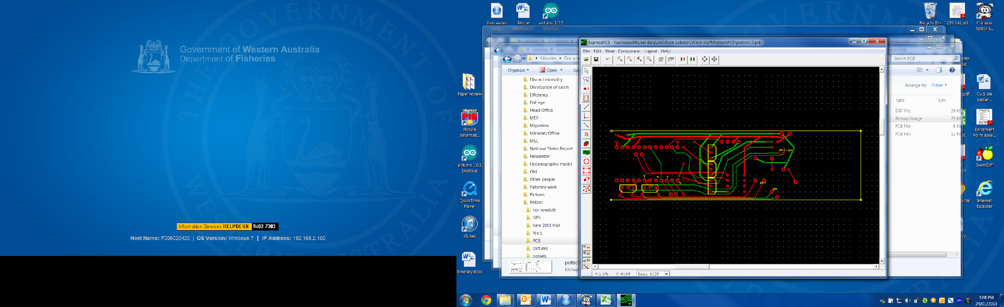

**Figure 3.** Schematic of the PCB board for the POTBot.

Following on from the initial development of POTBot v1 a number of improved versions of the 808 camera model were released (#11 in early 2012, #16 in mid-2012 and Mobius in early 2013). These versions had increased picture quality (full high definition: 1920 x 1080 px) as well as a 120o wide-angle lens and greater functionality. The #16 and Mobius could be pre-programmed (e.g. adjust auto-shut off and power down and video frame rates); with the Mobius capable of being programmed to take a video simply on power-up (did not therefore need its buttons to be triggered by the micro-controller). Although more expensive than the original #4 camera used in POTBot v1 the increases in price were outweighed by the increased performance of these cameras. As such the #11, #16 and Mobius were each included into sequential POTBot versions 2-4, respectively (Table 3).

**Table 3.** Upgraded cameras for use in POTBot versions 2-4.

|  |  |  |  |
| --- | --- | --- | --- |
| **Camera name** | **Source** | **Cost** | **Picture quality** |
| HD #11 Spy Camera Car Keychain DVR Video MOV Record 808 | Ebay #110710564362 | $38.98 | High |
| 808 #16 Car Key Chain Micro Camera Real HD 720P H.264 Pocket Camcorder Lens C | Ebay  #291416261090 | $45.21 | High |
| Mobius Action Camera Full HD 1080P 30FPS 720P 60FPS Sports Cam FPV Camcorder | Ebay  #351678603738 | $64.34 | High |

##### Global Positioning System

The Global Positioning System chosen was a PMB-648 GPS SiRF integrated with an internal antenna. The PMB-648 GPS module provides high performance with a SiRFstarIII chipset and integrated patch antenna. This was one of the more expensive internal components at $34.99 ([Sales@Parallax.com](MAILTO:sales@parallax.com)). The PMB-648 GPS features 20 parallel satellite-tracking channels for fast acquisition of NMEA0183 v2.2 data. It has a patch antenna; rechargeable battery for memory and Real Time Clock (RTC) backup; cable for power, and Transistor–Transistor Logic (TTL) and Recommended Standard-232 (RS-232) connections. This GPS proved very easy to use and incorporate into the POTBot v1. In its most basic setup the unit only requires to be powered and it automatically searches for satellites and returns NMEA data (National Marine Electronics Association). The NMEA standard is formatted in lines of data called sentences, with each sentence containing various bits of data organized in comma delimited format. The sentence chosen to strip out the position (latitude and longitude) and date/time was denoted by the header code “$GPRMC”, which contained a range of information including a time stamp, signal validity, latitude, longitude, speed (kn), true course and date. The GPS was switched on by the microcontroller via a NP transistor completing the earth of the GPS (Figure 2). The controller cannot by itself power many of the components as they generally required a current greater than the maximum current that can safely be supplied by any of the microcontroller’s pins (< 40 mA). It is far better practice to use the low current provided by the controller pins to turn a switch (NP transistor in this case) on and off and allow greater currents to flow through this switch directly from the power source (like turning on a light switch at home). This use of an NP transistor as a switch is discussed further below under section “Additional supporting components”.

##### Temperature Sensor

The temperature sensor chosen was a High-Precision Digital Thermometer (model number DS1631A). The DS1631A digital thermometer provides 9, 10, 11, or 12-bit temperature readings over a -55°C to +125°C range with an accuracy of ±0.5°C from 0°C to +70°C with 3.0V ≤ VDD ≤ 5.5V. The DS1631A automatically begins taking temperature measurements at power-up, which allows it to function as a stand-alone thermostat. Unit cost was $4. The Thermometer was switched on by the microcontroller via a NT transistor completing the power circuit (Figure 2). Trials of the DS1631A demonstrated that each unit required calibration.

##### Data Storage

For data storage the microSD ([Secure Digital](https://simple.wikipedia.org/wiki/Secure_Digital_card)) cards are the smallest storage cards available, measuring only 15 mm × 11 mm × 1 mm. Since, they can store information without continued power supply they were considered a perfect media for incorporation into the POTBot v1. The “Openlog” breakout board from SparkFun (<https://www.sparkfun.com/products/13712>) is a low cost (~$15), open source data logger that works over a simple serial connection and supports microSD cards up to 64GB. The Openlog can store or “log” large amounts of serial data (>MegaBytes). Upon power up it can be provided with information over a serial port that it will automatically record onto a microSD card. A pre-stored configuration file (“CONFIG.TXT”) saved to the microSD can be used to adjust the behaviour of the Openlog. In POTBot v1 the configuration file contained a single line of information “4800,26,3,1“. This represented the baud rate for communication between the Openlog and microcontroller (4800 bps), the ASCII value (in decimal form) for the escape character (26 is ctrl+z), the number of escape characters required (3 represents hitting ctrl+z three times to drop to command mode) and the system mode (set to 1 makes the Openlog append all information in the same file - a value of 0 results in a new file being created every time the Openlog is restarted). Using this breakout board to do all the complicated conversions and writing to the microSD reduces the demand on the Arduino Controller and simplifies the process. The Openlog was activated by the microcontroller via a NT transistor completing the power circuit (Figure 2).

##### Power Source

This project coincided with the expansion and popularisation of "lithium-ion” technology which was a major benefit. Initially rechargeable nickel-cadmium (Ni-Cd) and nickel-metal hydride (Ni-Mh) batteries were trialled to run the POTBot v1. Each AA battery produced 1.2 v, as such 3 AA batteries could be used to produce 3.6 v or four could be used to approximate 5 v (4.8 v). Since the #4 808 camera chosen for use ran on 3.7 v (they could handle up to 5.0 v) the latter option of 4.8 v was initially chosen. Generally a good quality AA battery contained up to 1000 mAh of power, however these were relatively expensive at $15 - $25 each (4.8 v worth could therefore cost up to $100). One issue that was discovered with the Ni-Cd and Ni-Mh batteries was that they could be overcharged and the four AA batteries could produce up to 5.4 v. Voltages over 5.0 could permanently damage the circuitry and/or components of the POTBot. The continued use of AA batteries as a power source was therefore considered less than optimal. This realisation coincided with the increase in availability of lithium-ion polymer (Li-Po) batteries, which had the advantage over the previous rechargeable batteries of being smaller, cheaper, more powerful (greater storage capacity) and they provided a constant 3.7 v (other constant voltages are also available). For example 5000 mAh Li-Po batteries can now be purchased for $30 on Ebay (five times the capacity for a third of the price of the old high quality Ni-Mh batteries). Following on from the move to a Li-Po power source, the POTBot versions 2 and 3 were built around a ~3.5 v operating voltage. The power source chosen, based on its capacity and physical size, was a 3.7 v, 3800 mAh Lithium Polymer Rechargeable Battery (Li-Po) with a built-in protection circuit (PCM) to prevent over charging or over discharging and a unit cost of $18. In POTBot v4 a move back to 5.0 v was made with the development of a large number of portable power packs designed for mobile phone charging (phones require 5.0 v for charging). The high demand of these units worldwide due to the wide use of mobile phones has resulted in their very low cost, while the high energy demands of mobile phones has resulted in these units having capacities well beyond what was previously available (10 000 mAh is not uncommon). In POTBot v4 the power source is likely to be 5600 mAh with a built-in protection circuit PCM and voltage converter at a unit cost of $25.

##### Additional Supporting Components

Additional components were required to allow the central control board to control the various components. These included five NP transistors (FB 51 PN100) whose primary role was to act as switches. When the Arduino board sends a small current to the transistor’s base pin it allows a connection to form across its two other legs (collector – emitter) allowing a current to pass. With this behaviour the resistor is essentially earthing its attached component and allowing it to run. Three, 220 Ohm resistors (band code = orange, orange, brown, gold) were required to minimise the amount of current that flowed into the transistors as they were “switched on” by the controller. The use of the resistors reduces excessive power draw by the transistors. A complete wiring diagram is provided in Figure 2.

##### Water Proof Housing

Waterproof housings are generally very expensive due to the high pressure environment they operate in and their need to be customised for a specific purpose. For the POTBot this was also the case as their housings had some additional specifications, they required a clear end piece for the camera to film through and they needed to be made of a material that would allow for the transmission of a satellite signal from the GPS (i.e. non-conducting material). Initial investigations suggested that professional purpose built housings were far too expensive to meet the low-cost demands of the project. The easiest and potentially the lowest cost alternative was to re-purpose a waterproof container. Underwater torch housings were the first option trialled (POTBot v1). Low cost underwater torches were available online and purchased to test their depth range. Of the three models available that suited the dimensions the POTBot one model proved water tight to over 150 m and for only $35 was chosen as the housing option. However, six months later the O-rings in these housings began to leak resulting in the destruction of a number of POTBot units. Upon further examination it appears that this housing was no longer being manufactured and an alternative needed to be found. High-pressure PVC pipe fittings were trialled next (POTBot versions 2 and 3). These required a small amount of manufacturing time for construction and their lens plate had to be specifically milled out of 8 mm polycarbonate. In materials they cost only about $30 per housing. Each housing was constructed from 110 mm of Vinidex 50 mm PVC Class 18 pipe (#13760), a class 18 Vinidex female-threaded 50 mm pipe v-socket (50 2 Valve T/O Adaptor #34090), a class 18 Vinidex 50 x 40 mm reducing coupling (#35020) with the 40 mm section sawn off, Hansen Glass Fibre Reinforced Nylon 50 mm screw cap (#SC50) and an 8 mm Perspex lens (Plate 2). These housings have been pressure tested and have remained water tight in depths of 180 m (deeper depths have not been trialled). In each housing two small stainless-steel screws pierce the wall to allow for an electrical current to be passed into the outside environment. A connection of current between the two external pins allows the unit to detect the presence of water and thus whether it is submerged or not. The housings have a screw-off end piece to allow for the removal of data and re-charging of the Li-Po power source. In POTBot v4 a slightly larger housing will be required. Although still under development it appears that the most appropriate construction material will again be PVC tubing.

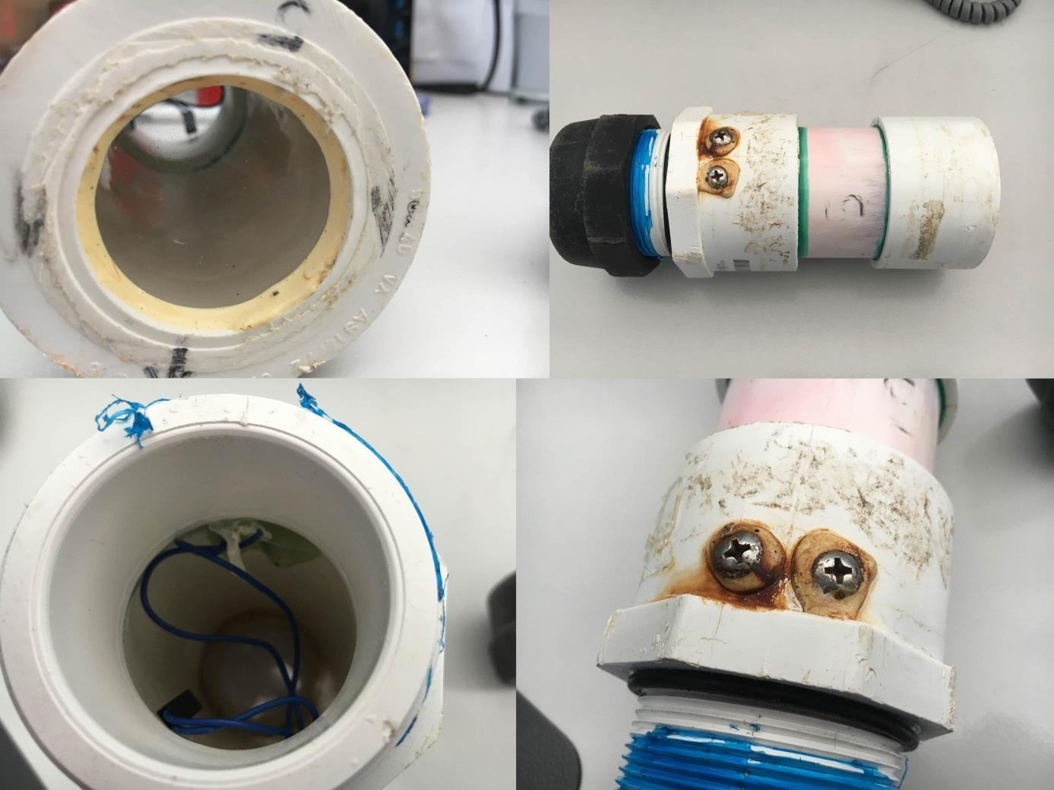

**C**

**D**

**B**

**A**

**Plate 2.** High-pressure PVC pipe fittings constructed as a water proof housing used in POTBot v2 and 3, showing clockwise from top right: A. entire housing with black screw cap on left, B. water sensing screw pins towards the centre and lens located on the right; C. closer shot of the water sensing screw pins with associated glue to ensure a tight seal; and D. internal view of the housing showing the wires connected to the internal aspect of the screw pins; front of the housing with its clear Perspex lens.

#### Placement in a lobster pot

An off-the-shelf non-metallic clamp system was sourced that allowed for a secure installation yet also a quick and easy exchange of POTBot units. Polypropylene Stauff Gr. 7 clamps were fitted using stainless-steel butterfly nuts to the rear-end of the lobster pots (Plate 3). This positioning provided the cameras an unimpeded view of the surroundings as the pot descended and meant that the unit was approximately 400 mm above the seafloor when the pot settled on the bottom. The unit cost for a pair of clamps with associated stainless steel threaded rod and butterfly nuts was ~$10.

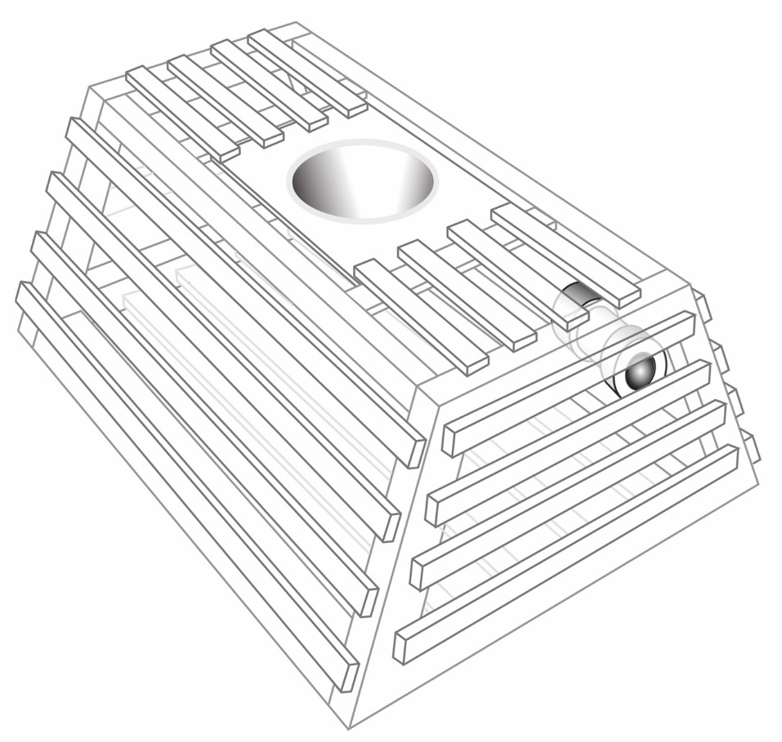

**Plate 3.** Schematic of a lobster pot showing the location of the POTBot.

#### Physical layout and construction

The POTBot was initially built on a breadboard and tested before a more robust prototype was developed. Its basic structure consisted of the central Arduino mini which was attached to a power source and four external components, the camera, the OpenLog, the GPS and the Thermistor (Figure 2). Upon the successful completion of breadboard trials, printed circuit boards (PCBs) were developed using the freeware software “ExpressPCB” (<https://www.expresspcb.com/>) with small production runs of PCB costing ~$35 each (this cost reduces markedly in larger production runs and from other suppliers) (Figure 3, Plate 4). Each PCB had holes for the attachment of the key components and their associated electrical components. The advantage of the PCBs is that they allow for the robust connection of all components in a standardised manner that is likely to withstand the rigors of being bounced around in a lobster pot.

Once soldered together the units were wrapped in protective foam insulation that kept them from moving when placed within the PVC water proof housings. Each POTBot took approximately three hours to build, load the code and placed in its housing. The batteries took about 3 hours to charge fully. The total cost of a POTBot (components and housing) was less than $250 (Table 4).

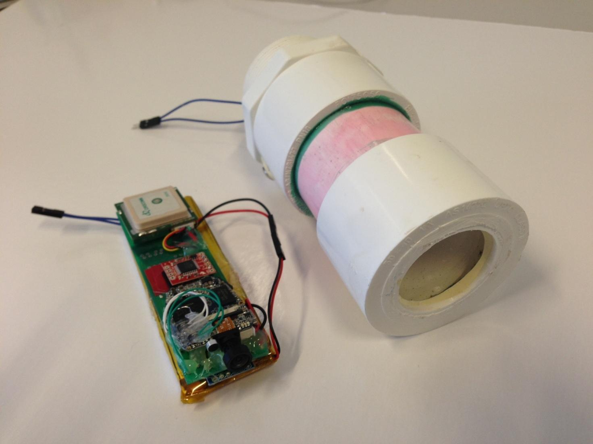

**Plate 4.** POTBot built on purpose-made PCB (green) with camera at the front, GPS visible towards the back and battery and Arduino mini located under the PCB; PVC underwater housing capable of deployments down to 180 m depth.

**Table 4.** Component costs for the development of POTBot version 3.

|  |  |
| --- | --- |
| ***Component*** | ***Cost*** |
| Controller (Arduino mini) | $15 |
| Camera (#16 808) | $45 |
| GPS | $35 |
| Thermometer | $4 |
| Openlog | $15 |
| 2 * microSD (10 Gb) | $15 |
| Underwater housing | $30 |
| PCB | $35 |
| LiPo battery | $18 |
| Bracket | $10 |
| 5 * NP transistors | $0.25 |
| 3 * resistors | $0.05 |
| **Total** | $222.30 |

#### Programming

The Arduino code is written in C++ and is uploaded to the controller using the Arduino software (<http://arduino.cc/en/Main/Software>). The POTBot code has been provided in Appendix 2. The software places the controller into a continuous loop of different states depending on the external stimuli it has received (Figure 4).

* The initial state (S1) cycles the controller into and out of sleep mode every 2 seconds (to save power) and tests, when awake, for input from the external pins to detect the presence of water.
* When detected the controller tests for water again, three successful sequential detections switches the unit into state two (S2) and activates the camera for 10 mins.
* Upon the completion of filming the unit enters state three (S3). In this state it cycles between sleeping and testing the environment, with continued detection of water keeping the unit in S3. Every one hour in S3 the unit records its temperature. A one hour lag is used to allow the unit to acclimate to the temperature of the surrounding environment. The unit records the temperature along with the time and date (the latter two data from its internal memory).
* A failure to detect water when in S3 results in the unit moving into state four (S4). In S4 the POTBot starts the GPS unit and continues to test for the presence of water.
* After a GPS fix is obtained the unit records its current location (retrieval location) and enters state five (S5) when it tracks its location for up to three hours (Figure 4).
* If the unit detects water it returns to S2 and records its most recent location (deployment location).
* If the tracking time (while in S5) extends past three hours the unit re-enters S1 (it is assumed that if it is not redeployed after three hours the pot will not be re-deployed for a considerable time and tracking the unit to get its next deployment location will consume too much power).

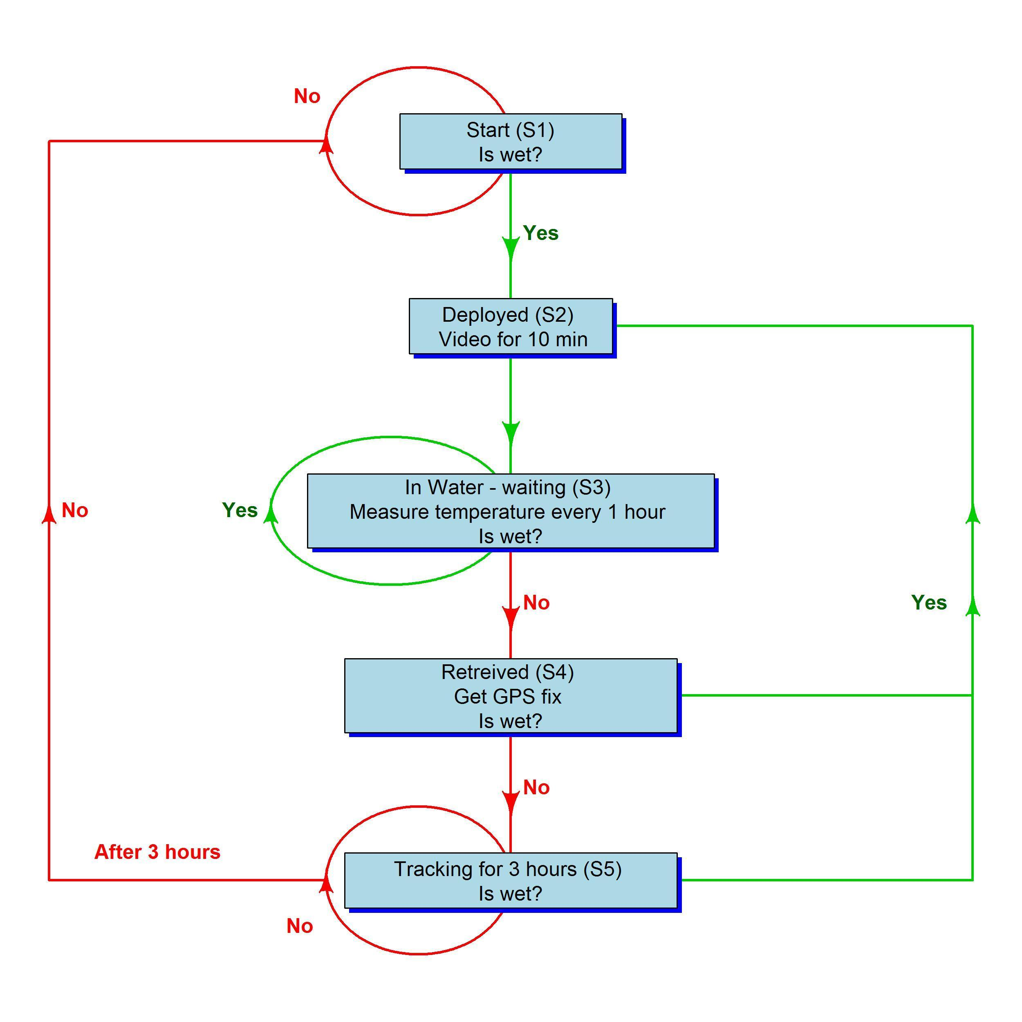

**Figure 4.** Flow diagram showing business rules followed by the POTBot versions 1-3 and its subsequent behaviour.

## Objective 2. Trial implementation of system by industry to test concept.

A trial implementation of POTBots with the fishing industry occurred during 2013 and 2014 fishing seasons and resulted in the collection of approximately 800 geo-referenced videos of benthic habitats and fish communities (Figure 5). This total was accumulated from more than 90 separate deployment trips with 17 different commercial fishers. During this period the lobster fishers typically pulled and reset their lobster pots every second day, thus collecting approximately 15 separate drop videos during a month-long camera deployment. This suited the memory and battery capacity of the POTBots. On the basis of this, a program was devised whereby fishers swapped a “used” POTBot over for a clean/charged model on a monthly basis, at which point they were also provided with all of the information (geo-referencing videos and water temperature readings) on a thumb drive.

In addition to the industry collected data, pot cameras were widely used during research potting with more than 500 fishery-independent data points collected. Habitat information has been collected throughout the fishery, spanning almost 6 degrees in latitude and a range of water depths (Figure 5).

The vison obtained for each POTBot deployment was used to classify the surrounding habitat and ecology based on a classification scheme developed under the Collaborative and Automated Tools for Analysis of Marine Imagery (CATAMI) project. This classification scheme uses standardised terminology for describing benthic substrates and biota in the marine environment (Althaus et al., 2015).

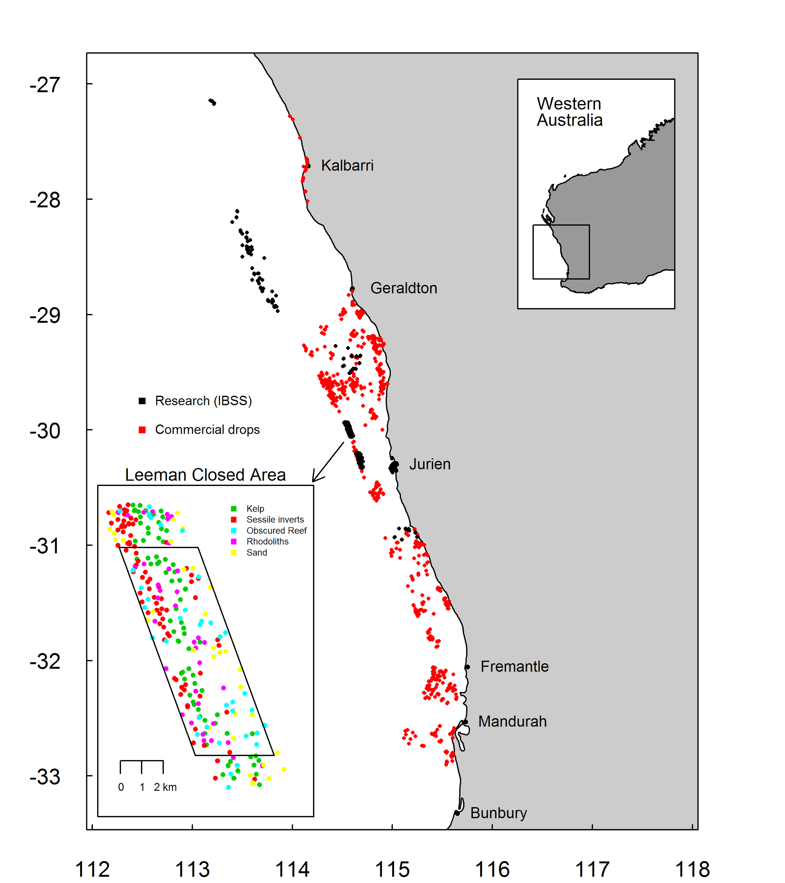

**Figure 5.** Map illustrating the spatial distribution of more than 1300 pot camera deployments made during research and normal commercial lobster fishing activities. The inset shows the key habitat categories observed inside and surrounding the research area at Leeman that is closed to lobster fishing and where high resolution bathymetric information was collected as part of FRDC 2008/013.

### Performance of POTBot v2 and 3

In a standard commercial lobster fishing operation, where pots are pulled every second day (average over a month) and are re-deployed with 30 mins of retrieval, the POTBot proved capable of recording the information of approximately one month (15 deployments). After this length of time the unit began to run out of power.

The majority of drops resulted in high quality footage which allowed the habitat to be easily observed. The low light sensitivity of the cameras allowed the collection of footage, sufficient in quality to identify and classify the habitat, in water depths down to 150 m, as long as the deployments occurred during the day. In rough and turbid conditions, the footage was still capable of providing vision from which the habitat could be described.

In 21% of the deployments the quality of the vision was not appropriate for classifying the habitat. The most common cause of poor quality footage was the orientation of the pot when it landed on the seafloor (Figure 6). When the pot lands on uneven ground it can point at an awkward angle to the sea floor making it very difficult to see the surrounding habitat. However, landing at an awkward angle did not always render the footage useless as quite often the habitat could be assessed as the pot descended through the water column towards the seafloor. Deployments during the night / very early morning and turbid conditions (due to wave action in shallower locations) also caused a number of videos to be rendered useless (Figure 6). System malfunctions were fairly uncommon (cause of only 15% of all problems, occurring in about 3% of all deployments) and declined over the course of the project as the construction of the units became more robust. The majority of malfunctions were related to power issues (batteries failing) or a soldered wire coming loose.

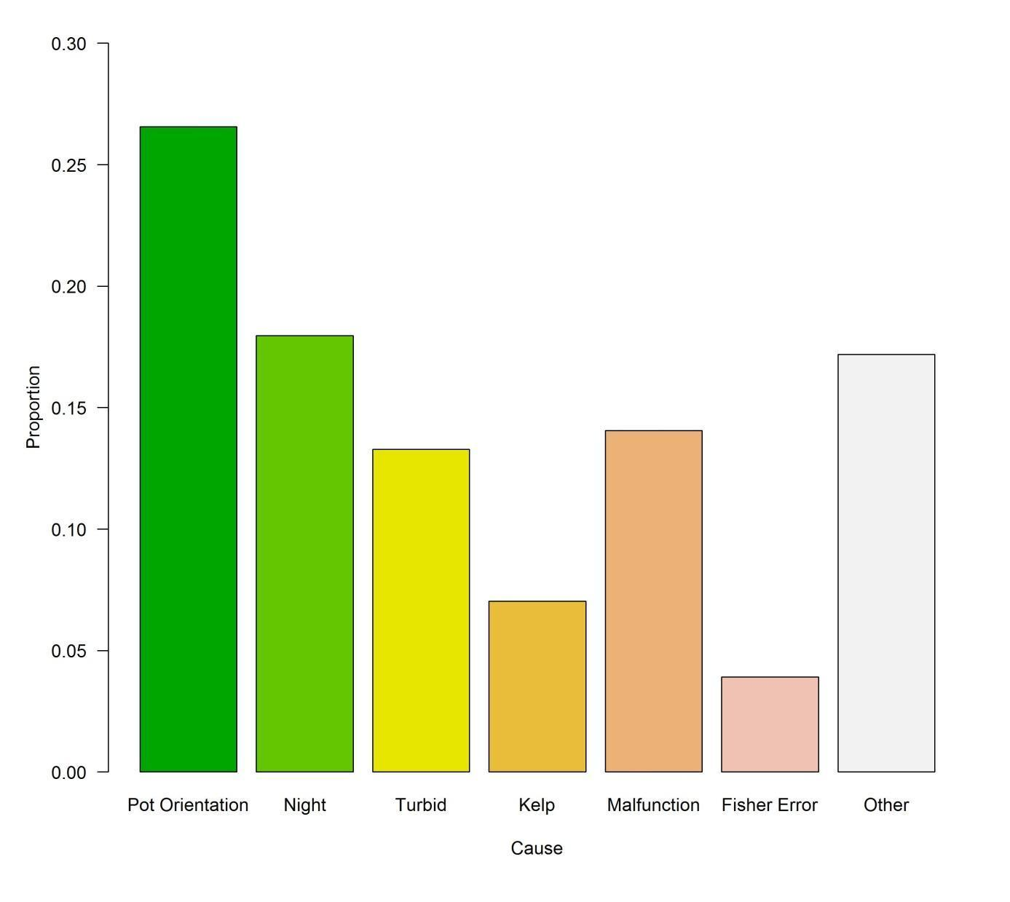

**Figure 6.** Relative causes resulting in a habitat classification not occurring from a POTBot deployment.

## Objective 3. Cost-benefit analysis with conventional ground-truthing techniques.

### Comparison of habitat mapping at the Leeman Closed area

The Leeman Closed area has been a focus for FD since 2010 as part of a study into the impacts of fishing for lobsters in deep water (FRDC project 2008/013). Part of this research has required the fine-scale mapping of the area using hydro-acoustic side-scan sonar, video tows, camera drops and POTBot data. Collectively these data have resulted in the development of a very high-resolution habitat map. This study has used this high-resolution map for comparison to assess the quality/accuracy of “lower quality” habitat maps produced for the same area based on the reduced data sets such as that produced by the POTBot or towed video studies. Two lower quality habitat maps were developed based on wither POTBot or towed/drop camera samples. The maps were developed using based on inverse distance weighted interpolation in the gstat package on the R platform (Pebesma, 2004; R Core Team, 2017). This method assigned a probability of habitat type to each unknown 1 m2 of the Leeman closed area based on the assignment of surrounding known habitats (from samples) and their distance from the point to be estimated. The greater the distance between known and estimate’s points lessens the influence of the known point on the habitat assignment.

Comparisons between the high quality habitat map and lower quality maps (produced from either POTBot or towed/drop sampling) were conducted by choosing 50 random locations from each of the lower quality habitat maps. These points were compared with the habitat assignment for the same 1 m2 locations from the high-resolution habitat map. The percentage of comparisons which matched between low and high quality maps was used as a measure of the lower quality maps accuracy (i.e. assumes the high quality habitat map was always correct).

The POTBot habitat data collected for this region were derived by placing units into research pots that were being fished as part of the lobster sampling project. These data were therefore collected for only the cost of the units (assuming they were only used this one time) [$250 for materials and $120 for construction by staff for each POTBot], or at no cost if these units were lying idle as sampling occurred during the closed period of the commercial fishery. As such the mapping of this entire area based on this data set cost a total of $7400 or nothing (the cost of processing the data is essentially the same as in the video tow/drop camera data set and therefore not used in their comparison). This data set has been compared to that derived from drop camera (Langlois et al., 2016) and tow-video surveys (Hovey et al., 2012) that were conducted in this region as part of the marine mapping program. The cost of these surveys was $80,800, which was comprised of vessel, staff and camera costs and was therefore at least about 10 times larger than the cost of the POTBot based survey (assuming that both these surveys were the only time these camera systems were to be used). From the two surveys 392 and 5072 data points were collected at a cost per data point of $18.88 and $15.93 for the POTBot and towed/drop surveys, respectively, under these assumptions. However it can be considered that the cost for both camera systems could be removed as they were previously owned assets, purchased for previous work. If the costs associated with the camera systems for each survey were removed, the POTBot survey was conducted for no costs (since they were deployed and retrieved for zero cost), while that of the drop camera and towed video surveys had a unit cost still of about $8 a sample (as they required staff and vessel time for deployment).

Both sets of studies provided a good coverage of the study area at Leeman (Figure 7), although it is noticeable that the tow video / drop camera data set had large numbers of sequential points that were not heterogeneously spread across the area. Both data sets contained sufficient points to produce habitat maps of the entire Leeman closed area (Figure 8). Although the resultant maps were overall relatively similar there were a number of areas where different habitats were predicted to dominate. The map based on the POTBot data set predicted that the western edge of the area was dominated by reef, while the eastern edge by sand, whereas the map based on the towed video/drop camera predicted reef dominating the entire southern region of the area, while the northern end was a mix of rhodoliths, obscured reef and reef (Figure 8). When randomly chosen points were selected from each habitat map and compared to the very high-resolution habitat map (produced by all data sources as well as side-scan sonar) both habitat maps showed good agreement with the high resolution map. The POTBot and drop camera/towed video studies agreed with the high resolution map in 25% (36 comparisons) and 13% (38 comparisons) of comparisons, respectively.

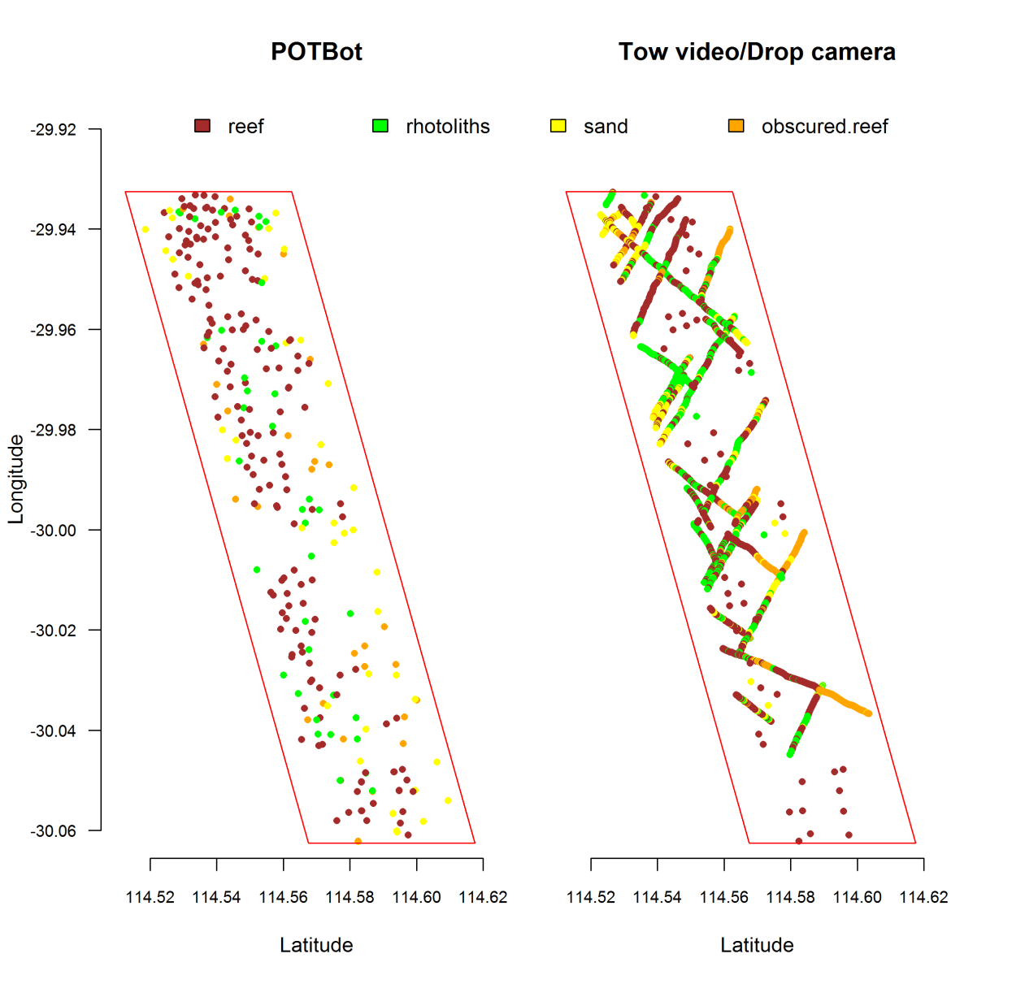

**Figure 7.** Maps showing the positions and habitat classification of samples collected by the POTBot (left) and drop camera / towed video (right) studies. The red border represents the limit of where the data were used to produce a habitat map.

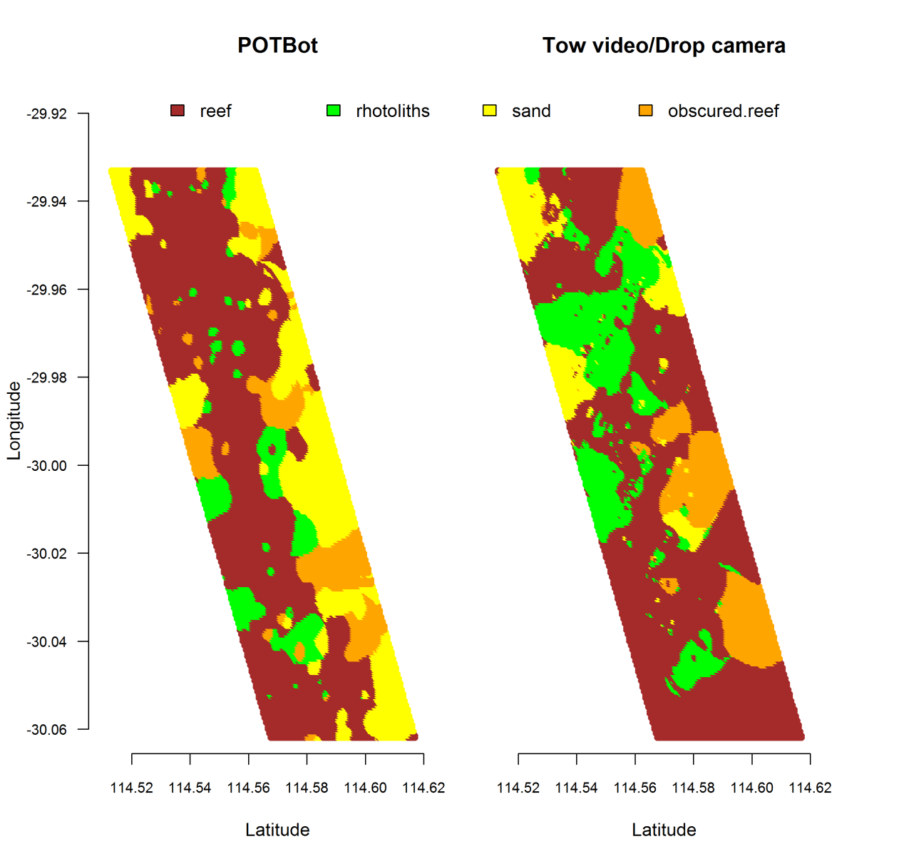

**Figure 8.** Habitat maps derived from data collected by the POTBot (left) and drop camera / towed video (right) studies.

### Comparison of visual-based fin-fish monitoring

A second comparison was made between the fin-fish study conducted by Brooker et al. (submitted) which was based on POTBot-derived data and a typical Baited Remote Underwater Video (BRUV)-based study over a similarly wide spatial area (Langlois et al., 2012).

For the POTBot-based fin-fish study 398 videos were collected across 750 km of coastline from 19 commercial fishing vessels using 20 POTBot units. The collection of these data cost approximately $7400 and comprised only unit costs ($370 unit-1). This resulted in a cost per video sample of $18.59. Furthermore, as there are essentially no on-going costs associated with this program, additional data can be added at no extra costs and the costs per sample will to decline. For example, the costs associated with all habitat samples collected during this study (1300 drops) have been collected at an individual sample cost of $5.70. The additional costs associated with processing the footage and recording fish species has not been included as it is consistent in this and the study by Langlois et al. (2012).

In the study by Langlois et al. (2012) footage was obtained using chartered vessels and university staff, which resulted in a far greater cost per sample. To study their nine locations, which spanned 1500 km of coastline, required 72 days of field work of which 54 days were on board charter commercial vessels. The total cost of vessel hire was ~$162,000, cost for staff was ~57,600 and the BRUV units cost $30,000. The total costs of $249,600 resulted in a unit cost of each sample being $173.33, or approximately 10 times that for POTBot fin-fish vision.

# Discussion

## Objective 1: Development of a cost-effective system for obtaining geo-referenced environmental information.

This project was successful in developing a low cost automated geo-referencing camera system that can be deployed throughout a number of commercial fishing operations (i.e. any operation which deploys fishing gear for an extended period of time). At a unit cost of approximately $250 this technology is far more accessible for wide-scale implementation than other, less autonomous products available. For example the popular system currently employed by a number of institutions (e.g. University of Oxford, England; Shahid Beheshti University, Iran; University of Cape Town, South Africa; University of Palermo, Italy) for implementation in baited remote underwater video systems (BRUVS; which still require user intervention to start videos and do not geo-reference their footage) cost over $400. The POTBot can replace these units at almost half the cost while also streamlining the process of deploying BRUVS due to their autonomous nature. By adjusting the various parameters of the POTBot it can perform the functionality of a BRUV system automatically, thus removing the need to start or stop any videos, or record their position.

The success of developing the POTBot is partly attributable to the recent rapid increase in the development of micro-electronic systems and robotics. Over the course of the project both lithium-polymer batteries and high-definition “spy” cameras became widely available in a range of sizes and at markedly reduced prices. Micro-controllers have also increased in their diversity and reduced in cost. This has allowed the POTBot to maintain a small size as well as low cost. For example, at the start of the project in 2013 most advanced small high-definition cameras, sufficiently high in quality that they could be used in stereo video applications to measure the lengths of moving fish, cost well in excess of $500. Now full high definition digital video cameras with high enough frame rates to conduct the same analysis can be purchased for less than $50. The small footprint of the POTBot has proved important for the fishers, primarily as they did not want marked changes being made to their fishing gear (i.e. reductions in pot volume). Their size also makes it easy to transport units back and forth between fishing vessels and the laboratory.

A fourth version of the POTBot is currently being developed. This model will be designed to eliminate some of the issues associated with versions 1 – 3 and will hopefully lead to an expansion in the use of this technology by other institutions. These earlier versions were quite complex to construct, as they needed someone familiar with the process and soldiering experience. This led to substandard builds and thus units that failed during operation. POTBot v4 will be designed to be more “plug-n-play” by containing a number of plugs for one to connect the various components. Versions 1 – 3 also did not have the ability to detect movement, an ability that adds substantial functionality. When deployed underwater, the addition of an accelerometer and/or magnometer, allows the unit to be programmed to collect additional footage as it is being retrieved. This process, in the context of a lobster fishing operation, will provide a better view (generally 360o) of the habitat as the camera will be facing directly down during the retrieval, thus removing all issues associated with pots not landing flat when deployed (i.e. the cause of poor footage in 21% of failed deployments). Detecting the retrieval process also allows for the GPS to be started earlier than previously, getting a faster fix once the system breaks the surface and thus a better estimate of the deployment location. The ability of the units sensing movement will also allow for reduced power consumption when on the surface. Rather than track a vessel between retrieval and deployment to obtain the pot deployment location, a unit sensitive to movement can obtain a location upon retrieval and then power-down the power-hungry GPS and then monitor movement at low power cost. When the pot is picked up off the boat’s deck prior to being deployed the unit can turn on the GPS and obtain the deployment position before the pot hits the water.

## Objective 2: Trial implementation of system by industry to test concept.

Analysis of both research and industry collected data is continuing. The habitats observed in most of the videos collected have been analysed based on their percentage contribution. The collated habitat information is providing a map of the key habitats fishers operate in across the extent of the fishery and currently being used to validate the fishery-wide habitat maps that have been developed from the outputs of a previous FRDC project (2008/013). These projects have directly resulted in the Marine Stewardship Council certification of the WCRLMF becoming free, for the first time, of any conditions under Principle 2 (Ecosystems).

Trial implementation of the POTBot has highlighted the various limitations in the units which most commonly led to poor footage being obtained. The main causes of issues were the orientation of the pot on the seafloor, night-time deployments and camera malfunctions. The fourth version of the POTBot will aim to improve the performance of the system as well as making it more user friendly to both construct and to adjust the programming. In the most recent POTBot version (v3) all of the components were soldered to the Printed Circuit Board (PCB) and only the battery is connected via a plug. Adjusting the parameters that control the behaviour of the system requires a re-loading of the software via the Arduino software. In POTBot v4 the aim will be to develop a PCB that can be populated with the various components by a professional manufacturing company at low cost, including a number of plugs, which will improve the structural integrity of the unit. The plugs will also allow for the attachment of a camera, GPS and battery by the end user. This has the advantages of allowing the end user to attach the various components in locations that suit their application and water proof housing. The parameters controlling the unit will be stored on the microSD card in a text file which is easily modified by any user without need for an understanding of C++ code or the Arduino software. For example, in the future to adjust the time length of the video taken the microSD card needs to be removed from the POTBot and plugged directly into a computer. A file on the microSD then can be opened in any of a number of common software programs (e.g. notepad or word) and the video length changed in a few keystrokes. Once the card is re-inserted into the POTBot and power supplied, the unit will automatically adjust its programming to suit the new video run-time.

Examination of fish community data from POTBot deployments highlighted the units’ versatility and cost-effectiveness as a fisheries-independent monitoring tool that can be deployed using existing infrastructure. Although comparison against spatio-temporal variation in similar fisheries-independent or -dependent indices is required, preliminary results suggest that the method has potential as an alternative means for monitoring relative abundance of fin-fish. Such data could be beneficial for stock assessment modelling and is highly applicable in both developed and developing countries.

A recent marine heat-wave in 2010/11 has resulted in a marked change in the benthic biota in the Kalbarri region (Wernberg et al., 2013). The result of this change in habitat has potential flow-on effects for the associated faunal compositions, thus affecting important commercial and recreational fisheries (e.g. lobster, abalone and scallops). However, due to the remoteness of this area and the fact that it is in a submerged environment there is little information available to determine to what extent the habitat has changed. Some data are available for the area from POTBots deployment and this has been useful in assessing that a change has indeed occurred. The fact that these data were collected at minimal cost (they were deployed during Western Rock Lobster fishing operations at zero cost) and the purpose of the collection was not specifically designed to determine the impact of a marine heat-wave (we did not know of its imminent arrival) highlights the value of maintaining the project into the future.

It is expected that the future version (v4) of the POTBot will be completed by the end of 2017. Their implementation into a number of studies has already been planned and plans for the units have been requested from a number of national and international research centres including (University of Western Australia, Murdoch University, University of New Caledonia and the Nova Scotian Government). It is hoped that, following the publication of a number of papers (one has been submitted), interest in this novel research tool will continue to grow.

## Objective 3: Cost-benefit analysis with conventional ground-truthing techniques.

The better performance of the map produced from POTBot data compared to that from drop camera/towed video data was possibly due to the random nature of the former’s deployment. This resulted in the data being spaced evenly over much of the region (see Figure 7), thus providing the geo-spatial model information across the entire area. The towed video component however was tightly linked spatially to subsequent samples (collected in strings) and therefore, although towed videos resulted in large numbers of samples, these are tightly grouped together and did not homogenously cover the entire area. The result of this was that areas such as the lower eastern edge of the region being studied had very little coverage from the towed video/drop camera data set, and subsequently the habitats predicted for this region were generally incorrect.

The mapping of the Leeman Closed area using POTBot data showed that, especially if an area is being fished for a separate purpose, the use of POTBots can produce fairly accurate habitat maps far cheaper when compared to the more traditional techniques. They also have the potential to continually collect data as the fishery will return to similar areas each season, as against once-off research studies. This is especially important under the guise of climate change as progressive increases in water temperatures will continue in this area as it is one of the hotspots of water temperature increases (Hobday and Pecl 2013) and are very likely to result in changes in the marine habitat.

A limitation of the POTBot project however, is that the exact placement of the system is at the mercy of the fishing fleet, and units may therefore not be deployed in areas where the target species does not commonly aggregate. This also has implication when the area to be mapped is located within an area closed to fishing as again the fishing fleet cannot enter.

For sampling fish populations BRUV footage, although far more expensive than POTBot derived footage, has some advantages, similar to that discussed above for the mapping comparison, in that they can be placed when and where the researches want them to go. Another advantage is that most BRUV systems are set up to collect stereo footage which allows for (but was not used in the case of Langlois et al. [2010]) the estimation of fish length. The POTBot sampling also had some advantages over that produced by the BRUVs. By the nature of commercial fishing, POTBots were set in a range of weather conditions. As a result Brooker et al (submitted) discovered that marked changes in fish abundance can occur in response to changing ocean conditions. This fact has never been reported from BRUV-based studies as these are generally conducted under relatively optimal weather conditions. Furthermore, although stereo vison is not obtained by POTBots, recent papers using known ratios of fish length to eye diameter show that the POTBot vison can be used to derive broad estimates of fish length on a scale that is appropriate for a number of activities (i.e. determining juvenile to adult ratios) (Zeidberg, 2004; Richardson et al., 2015).

The comparison between two fin-fish projects suggests that the monitoring of marine fauna can be conducted using POTBots at a fraction of the cost than using BRUVs, so long as the area of the study is shared with a commercial fishery willing to adopt the POTBot fishing program. In the case of the Langlois et al. (2012) study, only half of their study region overlaps with the WCRLMF, and they would have needed the associated help of fishers in the South Coast Crustacean Fishery to encompass their entire study region.

# Conclusion

This project has produced an autonomous geo-referencing camera system which has been shown to provide low cost monitoring of the habitats and fish communities throughout the WCRLMF. Their continued use will provide information for the assessment of climate change effects, such as the habitat changes that have occurred in the Kalbarri region following the 2011 marine heat wave (Wernberg et al., 2013). The usability (usefulness and value) of the system is highlighted by the fact that a number of other institutions, both nationally and internationally, have expressed their interest in acquiring this technology for use in their research operations.

# References

Althaus, F., Hill, N., Ferrari, R., Edwards, L., Przeslawski, R., Schönberg, C.H., Stuart-Smith, R., Barrett, N., Edgar, G., Colquhoun, J. and Tran, M., 2015. A standardised vocabulary for identifying benthic biota and substrata from underwater imagery: the CATAMI classification scheme. *PloS one*, *10*(10), p.e0141039.

Brooker, M.A. (2014). Fisher deployed baited video: A spatially expansive view of fish communities throughout Australia’s west-coast bioregion. Honours Research Dissertation, Faculty of Science; The University of Western Australia. 83 pp.

Brooker, M.A., Langlois, T.J., de Lestang. S., Fairclough, D.V., McLean, D., Slawinski, D., and Pember., M.B. (submitted). Fisher deployed automated videos reveal the influence of natural and anthropogenic factors on broad-scale fish abundance distributions.

Bellchambers, L., 2010. *The effect of western rock lobster fishing on the deepwater ecosystems of the west coast of Western Australia*. Fisheries Department of WA, pp. 90.

Bellchambers, L.M. and Pember, M.B., 2014. *Assessing the ecological impact of the western rock lobster fishery in fished and unfished areas*. Department of Fisheries, Western Australia, pp. 254.

Hobday, A, Pecl, G. 2013. Identification of global marine hotspots: sentinels for change and vanguards for adaptation action. *Reviews in Fish Biology and Fisheries*, 1-11.

[Hovey, R.K., Van Niel, K.P., Bellchambers, L.M. & Pember, M.B. (2012). Modelling deep water habitats to develop a spatially explicit, fine scale understanding of the distribution of the western rock lobster, Panulirus cygnus. *PloS one*, **7**, e34476.](http://paperpile.com/b/L9GTVH/VCxrZ)

[Langlois, T.J., Harvey, E.S., Fitzpatrick, B., Meeuwig, J.J., Shedrawi, G. & Watson, D.L. (2010). Cost-efficient sampling of fish assemblages: comparison of baited video stations and diver video transects. *Aquatic Biology*, **9**, 155–168.](http://paperpile.com/b/L9GTVH/W6t0L)

[Langlois, T.J., Harvey, E.S., Radford, B.T., Van Niel, K.P., Meeuwig, J.J., Pearce, A.F., Rousseaux, C.S.G. & Kendrick, G.A. (2012). Consistent abundance distributions of marine fishes in an old, climatically buffered, infertile seascape. *Global Ecology and Biogeography*, **21**, 886–897.](http://paperpile.com/b/L9GTVH/sxdB6)

Langlois, T.J., Heyns-Veale, E.R., Parker, D., Götz, A., Bernard, A.T.F. and Harvey, E.S., 2016. Insights from baited video sampling of temperate reef fishes: how biased are angling surveys?

Metcalf, S.J., Pember, M.B. and Bellchambers, L.M., 2011. Identifying indicators of the effects of fishing using alternative models, uncertainty, and aggregation error. *ICES Journal of Marine Science*, *68*, pp.1417-1425.

Pebesma, E.J., 2004. Multivariable geostatistics in S: the gstat package. Computers & Geosciences, 30: 683-691.

R Core Team (2017). R: A language and environment for statistical computing. R Foundation for Statistical Computing, Vienna, Austria. URL <https://www.R-project.org/>.

Richardson, J. R., Shears, N. T., and Taylor, R. B. (2015). Using relative eye size to estimate the length of fish from a single camera image. *Marine Ecology Progress Series*, *538*, 213-219.

[Wernberg, T., Smale, D.A., Tuya, F., Thomsen, M.S., Langlois, T.J., de Bettignies, T., Bennett, S. & Rousseaux, C.S. (2013). An extreme climatic event alters marine ecosystem structure in a global biodiversity hotspot. *Nature Climate Change*, **3**, 78–82.](http://paperpile.com/b/L9GTVH/OaZHI)

Zeidberg, L. D. (2004). Allometry measurements from in situ video recordings can determine the size and swimming speeds of juvenile and adult squid *Loligo opalescens* (Cephalopoda: Myopsida). Journal of experimental biology, 207(24), 4195-4203.

# Implications

The POTBot system proved valuable in the mapping and long-term monitoring of marine habitats. The advent of the marine heatwave highlighted the benefits of long-term datasets tracking the floral and faunal compositions of the marine environment, data that can only be collected by a system such as the POTBot. The continued use of this technology by multiple institutions around Australia will prove invaluable in assessing the longer-term impacts of global warming.

# Recommendations

The POTBot system developed during this study proved to be an extremely useful research tool. This has been highlighted by the fact that data collected during this project have already been used to describe the faunal composition of teleosts along the mid-west coast of Australia, as well as to augment the development of habitat maps throughout the same area.

Through the use of this technology information on habitats in remote areas has been recorded for the first time, information that will be valuable when determining long-term environmental changes in the future. Such a case has already occurred, following the marine heatwave of 2011.

It is recommended that, when appropriate, this technology should be adopted by other research institutions to gather this previously inhibitively expensive data and long term data sets should start to be collated.

# Further development

The most recent POTBot system developed during this study (v3) contained a few minor limitations, such as no ability to determine its movement/orientation. Since the conclusion of the project, work has continued, in conjunction with the University of Western Australia’s School of Electrical, Electronic and Computer Engineering, in the development of an improved POTBot model that will be more robust, have added capabilities and will be more user friendly. It is planned that the schematics of this model will be freely available for use by other research organisations.

# Extension and Adoption

The POTBot program has been adopted by FD and is planned to be included as an annual project (continued supply to fishers to increase habitat coverage). One scientific journal article and an Honours thesis from UWA have been based on data collected from the POTBot program. Two additional papers are currently under construction, and as more data are collected further papers will be developed. All habitat data collected by the program have been provided to the Oceans Institute at UWA for their use in developing habitat maps for the west coast of Australia. The data collected by commercial fishers using POTBots during this project has already contributed to the development and validation of bioregion-wide distribution models of benthic primary producers predicted from bathymetry datasets, which will be published shortly.

Presentations on this project have been provided to the West Australian fishing industry and wider scientific community at a number of meetings including Western Rock Lobster Annual Management Meetings and the 9th (Canada) and 10th (Mexico) International Meeting on Lobster Biology and Management.

A number of other institutions have expressed their interest in obtaining units for use in their research programs. These include UWA, Tasmanian Aquaculture and Fisheries Institute, the National Autonomous University of Mexico, South Australian Research and Development Institute and Florida Fisheries and Wildlife.

# Project Coverage

Preliminary details of the project have been communicated to both national and international audiences including ecologists, stock assessment scientists and fisheries managers with a presentation “*POTBot: A cost effective approach to mapping habitats*” being presented at

* The 9th International Conference and Workshop on Lobster Biology and Management (Bergen, Norway).
* Australian Marine Science Association 2011 Annual Conference (Fremantle, Australia)

Initial results of the project have been communicated in a poster presentation “*An industry-based approach to regional-scale monitoring of benthic ecosystems*” presented at both

* The 10th International Conference and Workshop on Lobster Biology and Management (Cancun, Mexico).
* The 10th International Temperate Reef Symposium (Perth, Australia)

Details of the project have also been widely communicated within the FD and nationally within the CSIRO.

A media statement introducing the project to the public was released in December 2011. As a result, the project received wide coverage on television (Channel 10), radio (ABC Rural; 6PR), and online media (below).

The West Australian online: <http://au.news.yahoo.com/thewest/video/watch/27487441/12735368/51/>

ScienceWA: <http://www.sciencewa.net.au/topics/fisheries-a-water/item/1136-robots-used-to-spy-on-rock-lobster-pots>

Perthnow: <http://www.perthnow.com.au/news/special-features/underwater-robots-to-spy-on-fisheries/story-e6frg19l-1226214217898>

Couriermail online: <http://www.couriermail.com.au/ipad/underwater-robots-to-spy-on-fisheries/story-fn6ck4a4-1226214548164>

Details of the project were also disseminated in the Department’s email newsletter WA Fish eNews (09/12/2011 ed.), which has a targeted subscription of more than 600 including many commercial fishers. A preliminary story has also been posted on the Department’s youtube channel. An updated video will be posted before the end of the project <http://www.youtube.com/user/fisherieswa/feed>

# Project Materials Developed

Brooker, M.A., Langlois, T.J., de Lestang, S., Fairclough, D.V., McLean, D., Slawinski, D., Pember, M.B. (submitted). Fisher deployed automated videos reveal the influence of natural and anthropogenic factors on broad-scale fish abundance distributions.

Brooker, M.A. (2014). Fisher deployed baited video: A spatially expansive view of fish communities throughout Australia’s west-coast bioregion. Honours Research Dissertation, Faculty of Science; The University of Western Australia. 83 pp.

# Appendix 1.

List of researchers and project staff:

Matthew Pember (formerly with DPIRD).

Senior Resource Access Officer.

Western Australian Fishing Industry Council

Phone: +61 08 9432 7715

Fax: +61 08 9432 7700

Email: rao@wafic.org.au

Simon de Lestang.

Principal Research Scientist.

Department of Primary Industries and Regional Development; Fisheries Division

Phone: +61 08 9203 0174

Email: Simon.delestang@fish.wa.gov.au

Dirk Slawinski.

Senior Experimental Scientist

Commonwealth Scientific and Industrial Research Organisation

Email: Dirk.Slawinski@csiro.au

# Appendix 2. POTBot code.

See: <https://github.com/sdelestang/POTBot>